SCHOOL OF COMPUTER SCIENCE AND ARTIFICIAL INTELLIGENCE |  |  |  |  | DEPARTMENT OF COMPUTER SCIENCE ENGINEERING
Program Name: B. Tech |  |  |  | Assignment Type: Lab |  |  | Academic Year:2025-2026
Course Coordinator Name |  |  |  | Venkataramana Veeramsetty
Instructor(s) Name |  |  |  | Dr. V. Venkataramana (Co-ordinator)  Dr. T. Sampath Kumar  Dr. Pramoda Patro  Dr. Brij Kishor Tiwari  Dr.J.Ravichander  Dr. Mohammand Ali Shaik  Dr. Anirodh Kumar  Mr. S.Naresh Kumar  Dr. RAJESH VELPULA  Mr. Kundhan Kumar  Ms. Ch.Rajitha  Mr. M Prakash  Mr. B.Raju  Intern 1 (Dharma teja)  Intern 2 (Sai Prasad)  Intern 3 (Sowmya)  NS_2 ( Mounika)
Course Code |  |  | 24CS002PC215 | Course Title |  | AI Assisted Coding
Year/Sem |  |  | II/I | Regulation |  | R24
Date and Day  of Assignment |  |  | Week9 - Thursday | Time(s)
Duration |  |  | 2 Hours | Applicable to  Batches
AssignmentNumber:17.4(Present assignment number)/24(Total number of assignments)
 | Q.No. | Question |  |  |  |  |  | Expected Time  to complete
 | 1 | Lab 17 – AI for Data Processing: Data Cleaning and Preprocessing Scripts  Lab Objectives:  - Learn how to clean raw datasets using AI-assisted Python scripting.  - Apply preprocessing techniques such as handling missing values, encoding categorical data, and normalization.  - Automate repetitive data-cleaning tasks with AI-generated code.  - Understand how preprocessing impacts model performance.  Task 1 – Employee Data Preprocessing  Task:  Use AI to generate a Python script for cleaning an employee dataset.  Instructions:  - Handle missing values in columns (salary, department, joining_date).  - Convert the "joining_date" column into proper datetime format.  - Standardize department names (e.g., "HR", "hr", "Human Resources" → "HR").  - Encode categorical variables (department, job_role).  Expected Output:  - A cleaned Pandas DataFrame with consistent departments, proper dates, and encoded features.  CODE:  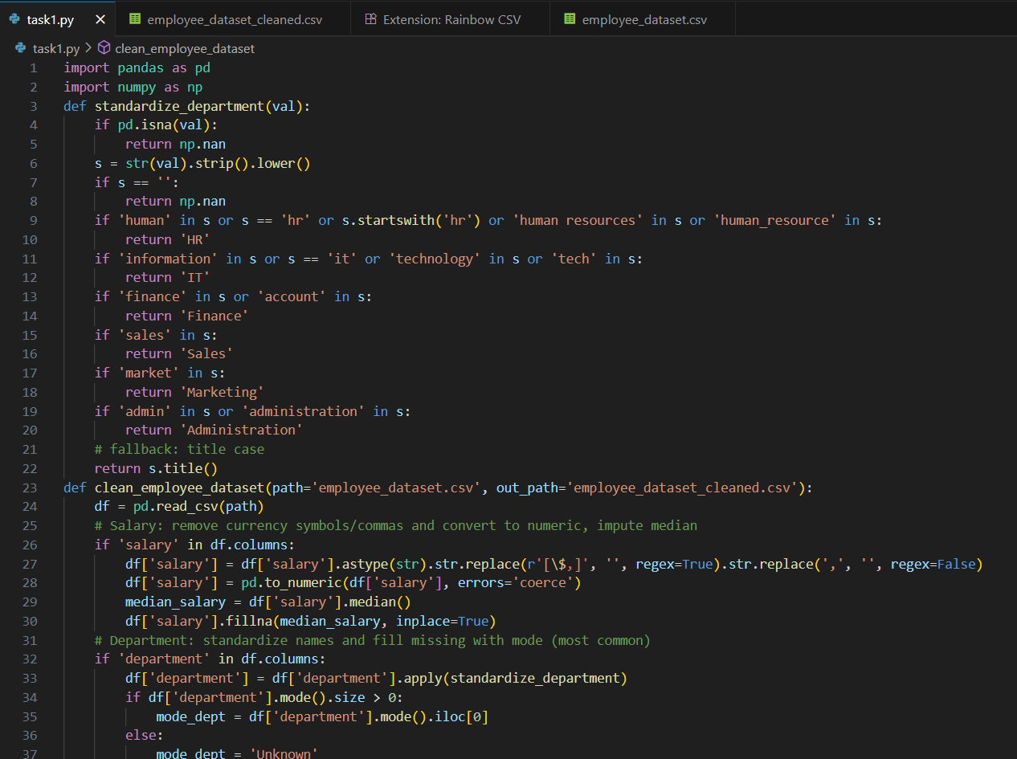  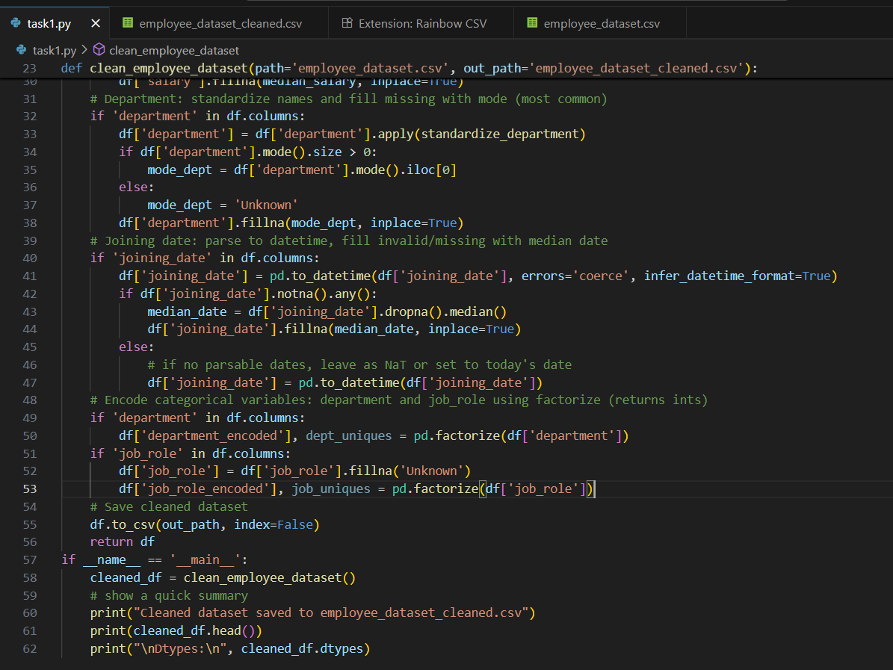  OUTPUT:  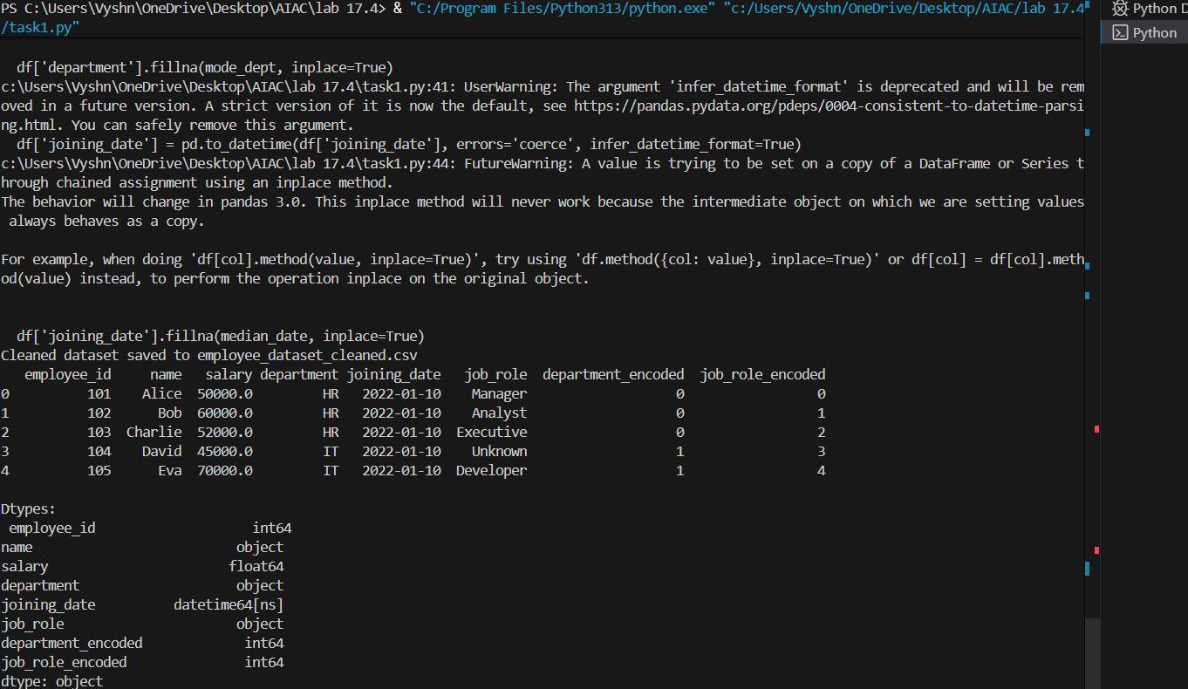  DATASET: 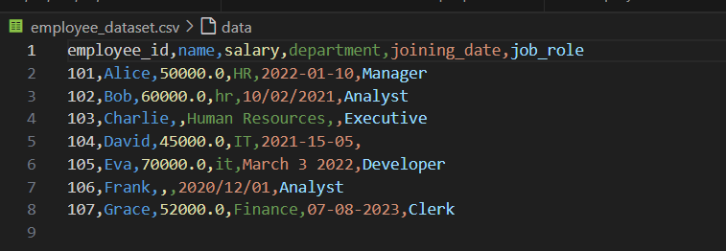  CLEANED FINAL DATASET OUTPUT:  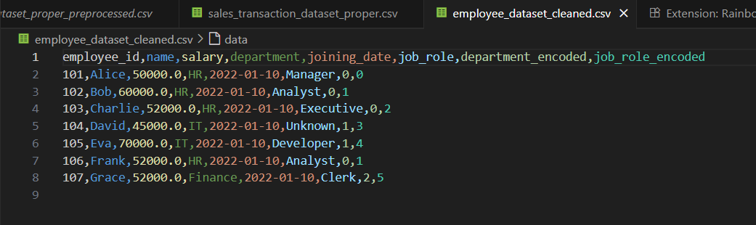  Task 2 – Sales Transaction Data Preprocessing  Task:  Use AI to generate a script for preprocessing a sales transaction dataset.  Instructions:  - Convert transaction dates to proper datetime format.  - Create a new column for “Month-Year” from the transaction date.  - Remove rows with negative or zero transaction amounts.  - Normalize the "transaction_amount" column using Min-Max scaling.  Expected Output:  - A preprocessed DataFrame with valid dates, normalized amounts, and no invalid records.  - CODE:  - 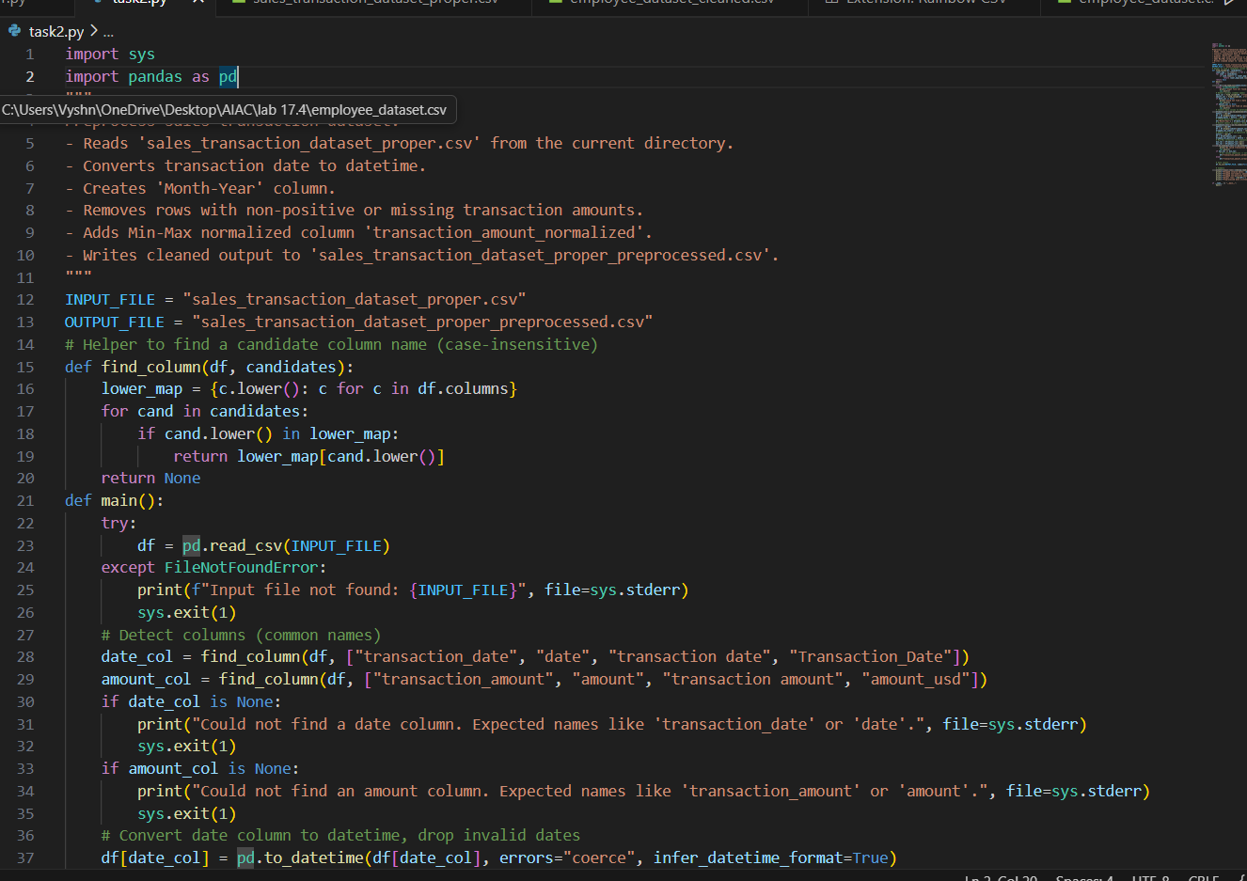  - 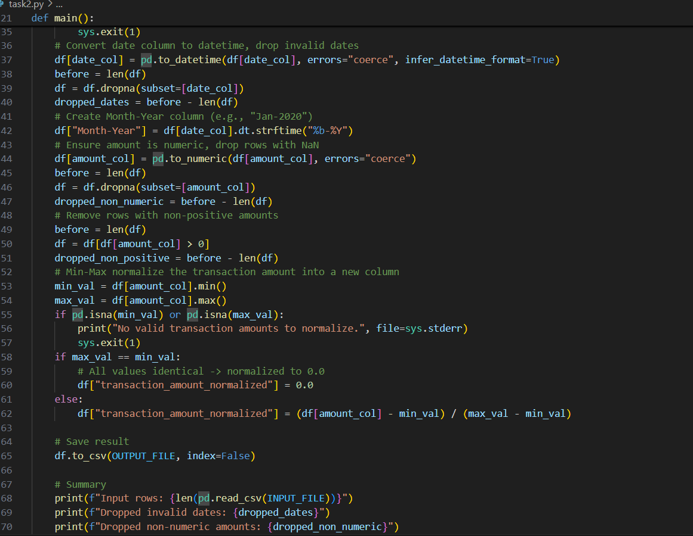  - 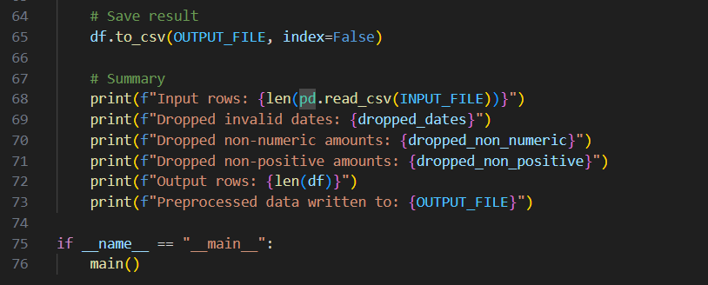  OUTPUT:  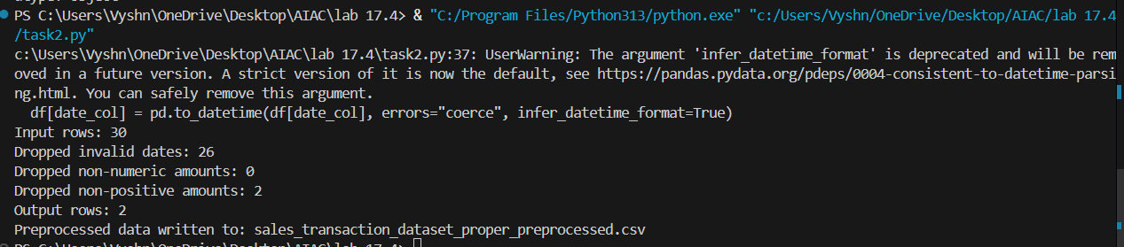  DATASET CSV FILE:  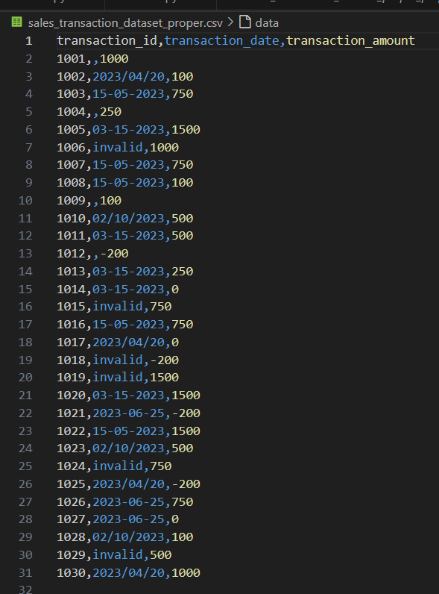  Final cleaned data output  : 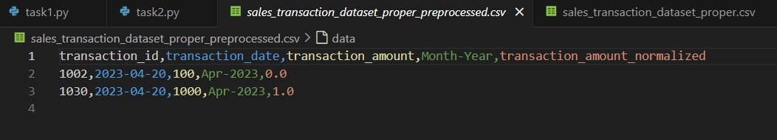  Task 3 – Healthcare Patient Records Cleaning  Task:  Use AI to generate a script for cleaning healthcare patient records.  Instructions:  - Fill missing values in numeric columns (e.g., blood_pressure, heart_rate) with column mean.  - Standardize units (convert height from cm to meters).  - Correct inconsistent categorical labels (e.g., "M", "Male", "male" → "Male").  - Drop irrelevant columns such as patient_id after cleaning.  Expected Output:  - A cleaned healthcare dataset suitable for ML model training.  - CODE:  - 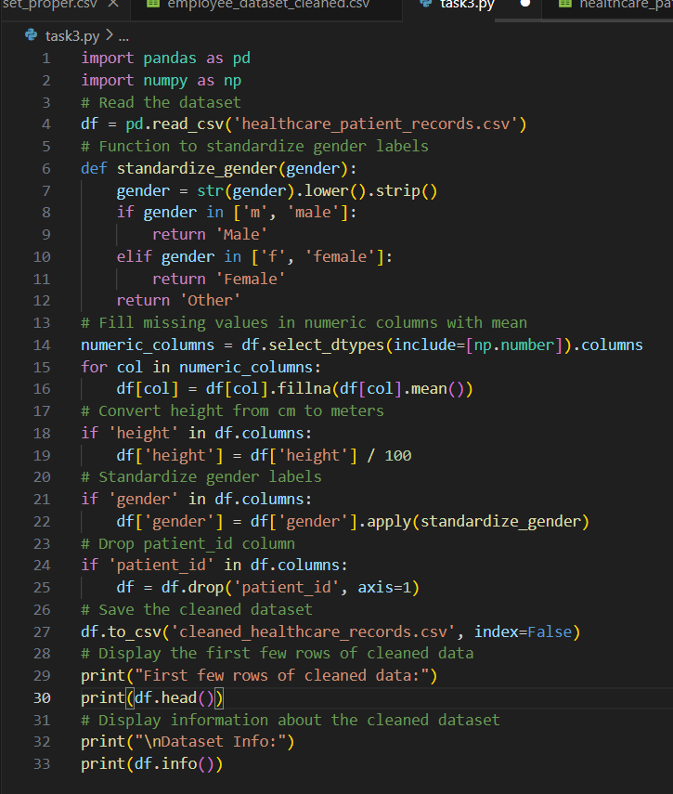  - OUTPUT:  - 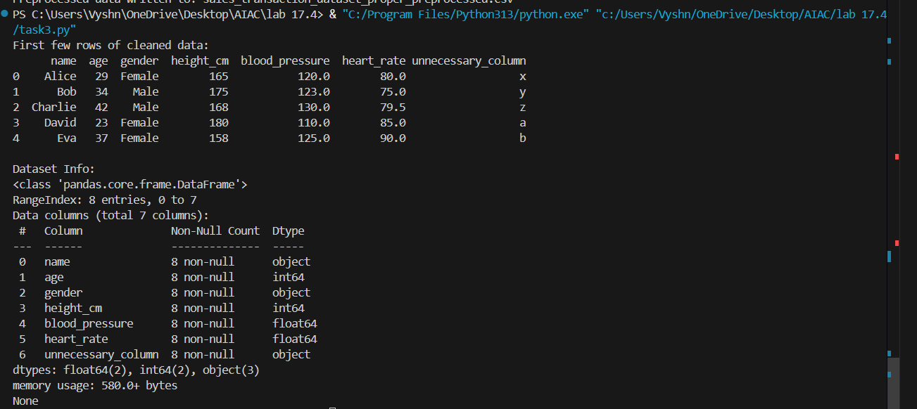  - DATASET :  - 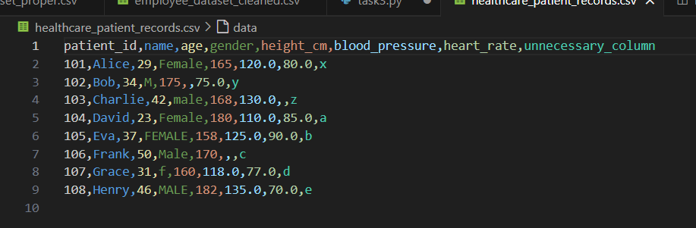  - FINAL CLEANED DATASET:  - 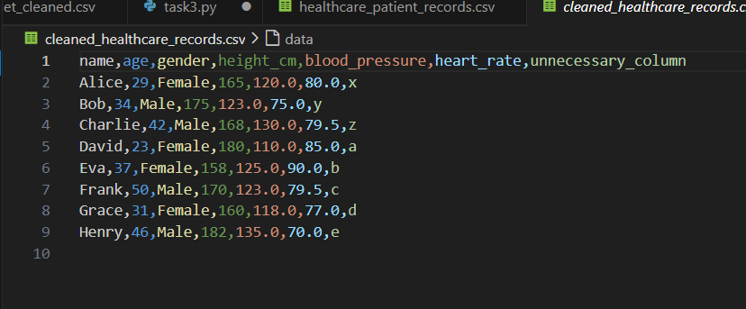  Task 4 – Social Media Sentiment Dataset Preparation  Task:  Use AI to write a script to preprocess a social media text dataset.  Instructions:  - Remove special characters, URLs, and emojis from text.  - Convert all text to lowercase.  - Tokenize and remove stopwords.  - Apply lemmatization for standardizing words.  Expected Output:  - A processed dataset with clean text, ready for NLP sentiment analysis.  - CODE:  - 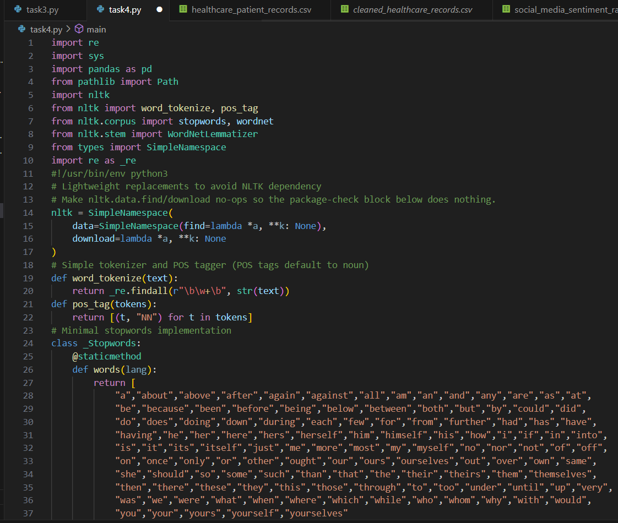  - 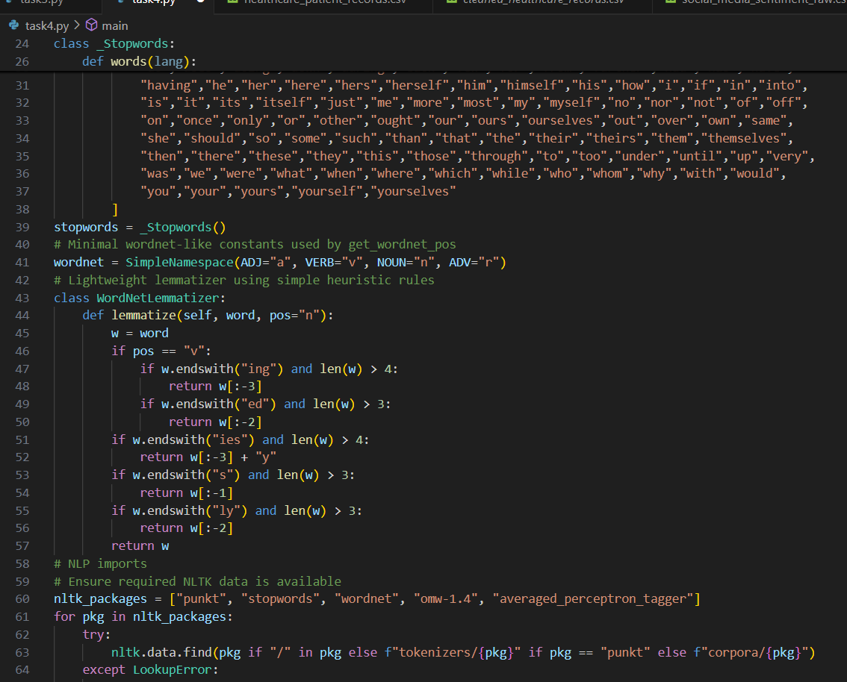  - 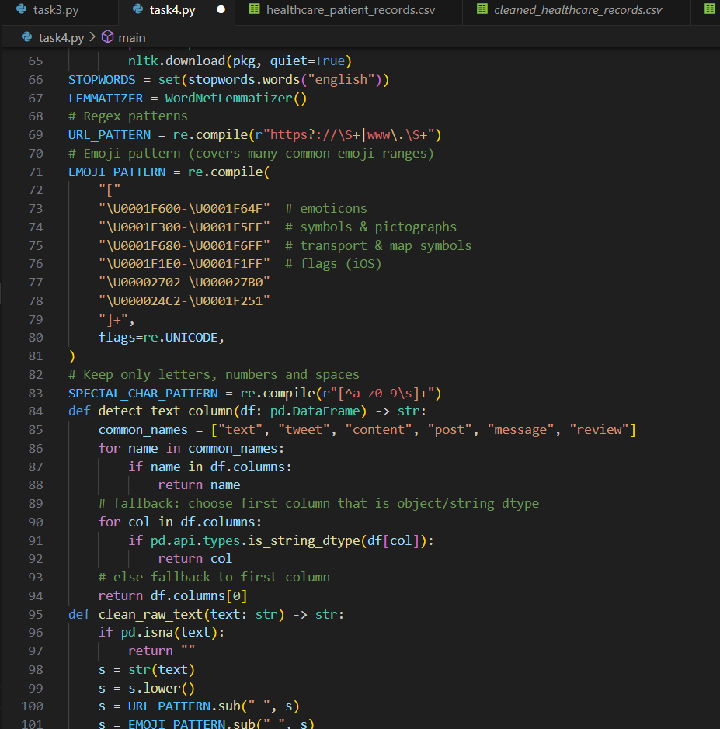  - 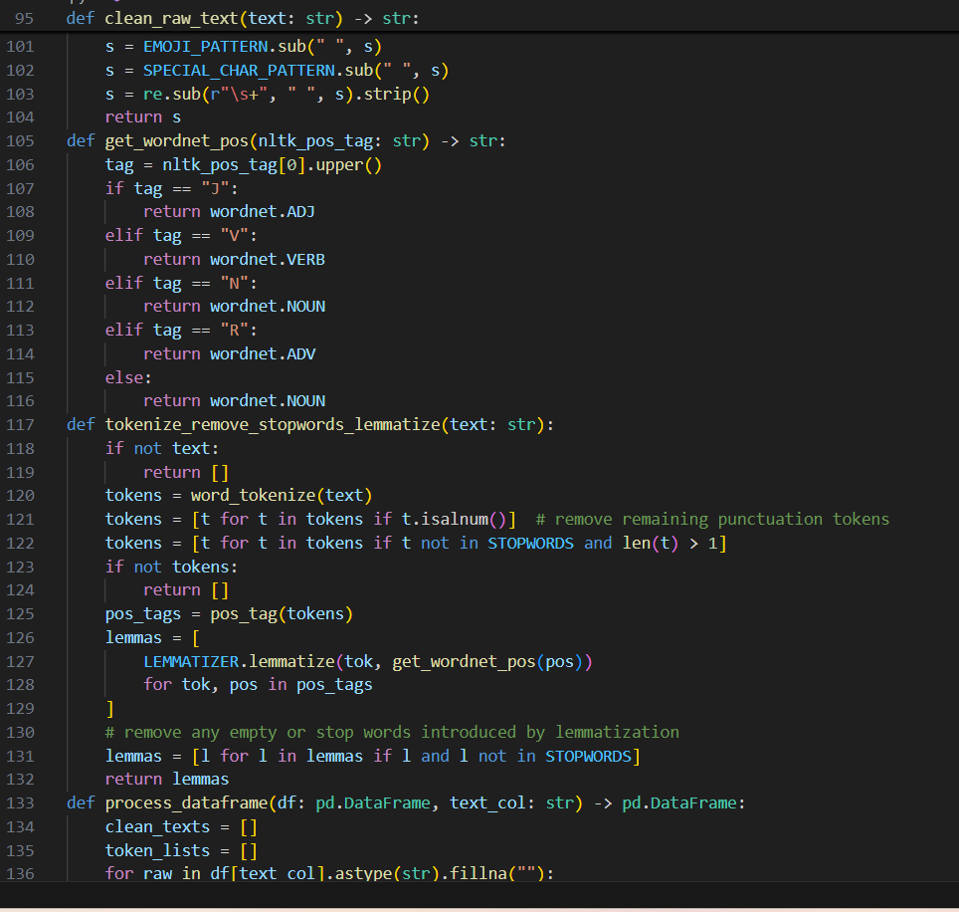  - 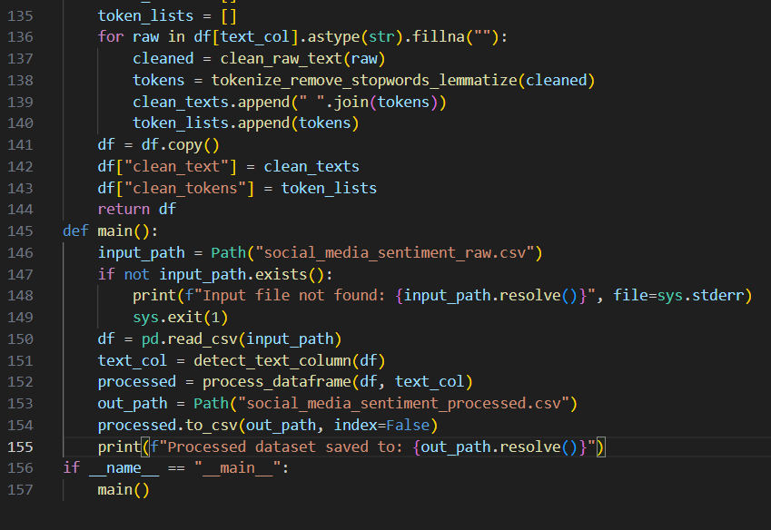  - OUTPUT EXPECTED:  - 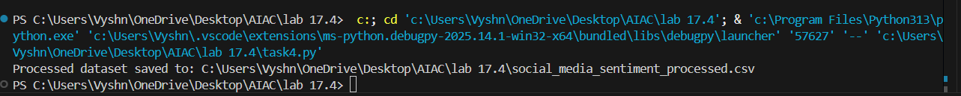  - DATASET:  - 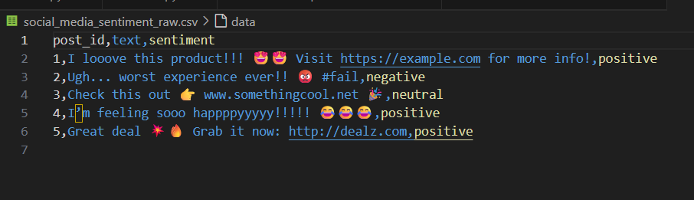  - FINAL CLEANED CSV FILE:  - 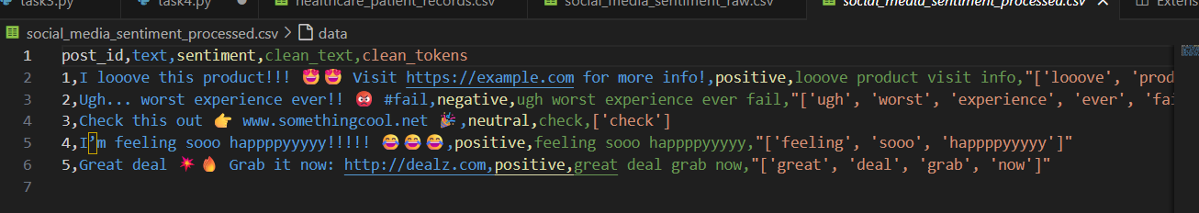  Task 5 – Financial Dataset Feature Engineering  Task:  Use AI to create a preprocessing script for a financial dataset.  Instructions:  - Handle missing values in stock price and volume.  - Create new features such as moving average (7-day, 30-day).  - Normalize continuous variables using StandardScaler.  - Encode categorical columns (sector, company_name).  Expected Output:  - A feature-engineered DataFrame with new indicators and normalized values for ML tasks.  CODE:  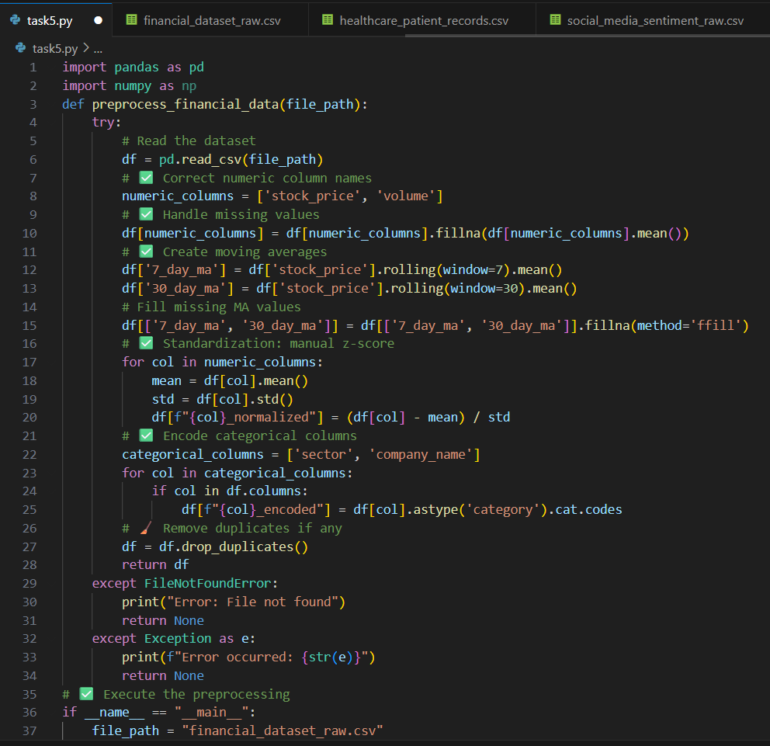  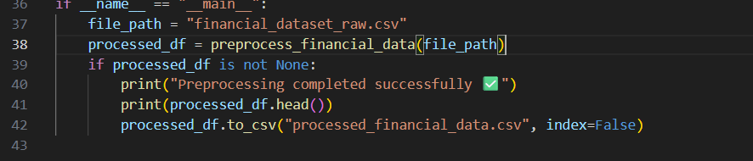  OUTPUT: 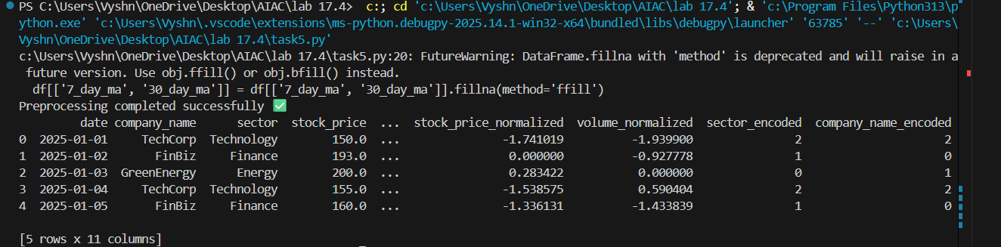  RAW DATASET :  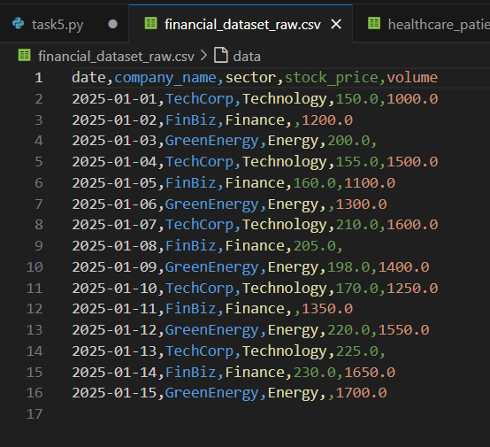  FINAL CLEANED DATASET:  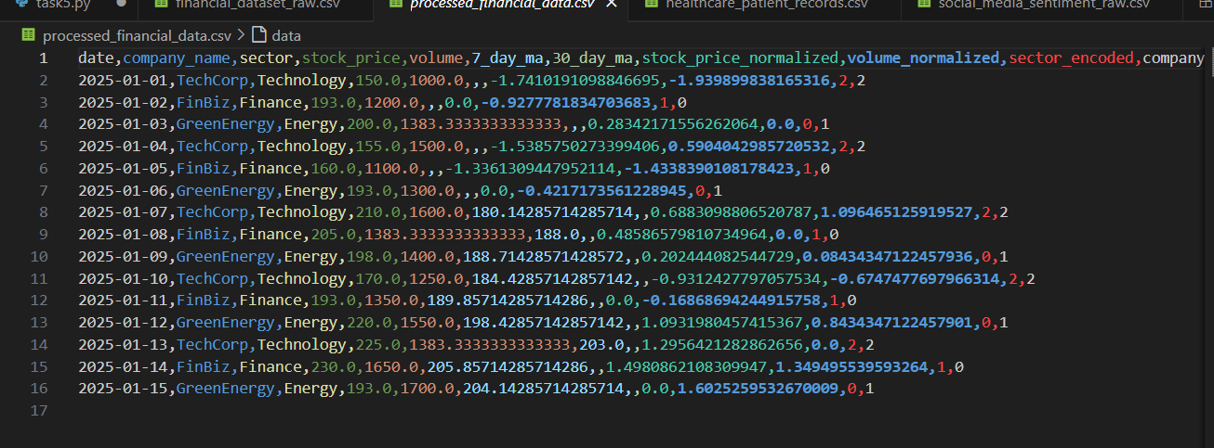  ✅ Deliverables (For All Tasks)  - AI-generated prompts for code and test case generation.  - At least 3 assert test cases for each task.  - AI-generated initial code and execution screenshots.  - Analysis of whether code passes all tests.  - Improved final version with inline comments and explanation.  - Compiled report (Word/PDF) with prompts, test cases, assertions, code, and output. |  |  |  |  |  | Week9 - Thursday

